Lab 13

Title

Structure

Objective

The students will learn and apply the

Introduction
In C++, a structure (struct) is a user-defined data type that allows grouping variables of different data types under a single name. Structures are useful when dealing with complex data where multiple attributes are required to represent an entity, such as a student record or employee details.

Theory
A structure is defined using the struct keyword. It can contain variables of different types such as integers, floats, and characters.
Syntax
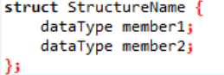
- Each variable inside the structure is called a member.
- Structure variables can be accessed using the dot (.) operator.

Conclusion:
In this lab, we learned how to use structures in C++ to store and manage multiple related data items. Structures improve program organization and make handling complex data easier.
Lab 13 Tasks

1. Structure Declaration and Initialization
- Declare a structure called Person with the following members:
name
(string)– age
(integer)
address (string).
- Declare a variable called person1 of type Person and initialize its members with
- values of your choice.
- Display the values of the members of person1 using dot notation.

Code:
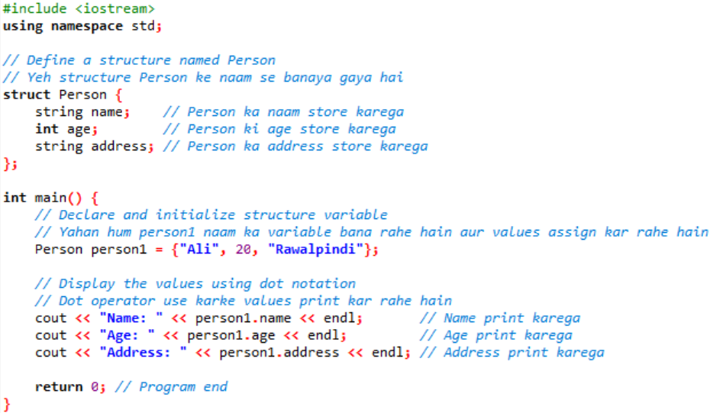

2. Structure Declaration and Initialization
- Declare a structure called Student with the following members:
(name)
(string)– age
(integer)
grade (char)
- Declare a variable of type Student called student1 and initialize its members with
values of your choice.
- Display values of student1 structure members.
Code:

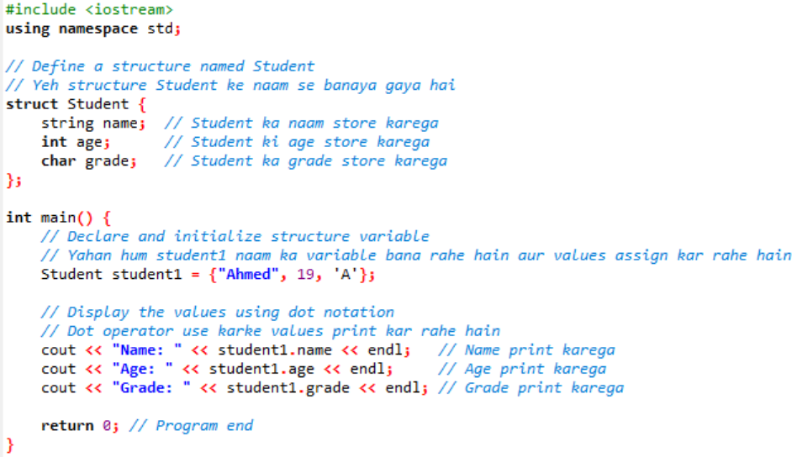

3. Accessing Structure Elements
- Declare a structure called Book with the following members:
title (string)
author
(string)– price
(float)
pages (integer)
- Declare a variables of type Book called book1 and book2, anmd initialize its
- members with values of your choice.
- Display values of structure members of variables book1 and book2 .

Code:
